# Exercise 1:

1.

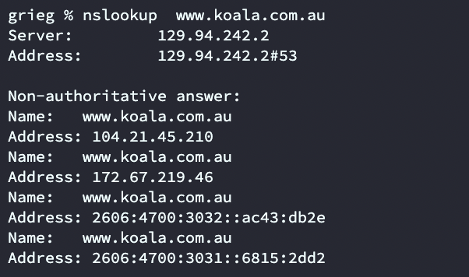

129.94.242.2 and Non-authoritative answer’s address are all the address of the website. Because a domain name corresponds to multiple physical addresses (servers), when a user accesses it, it will be answered by one of the computers according to certain rules. If it supports IPV6 then it will have an IPV6 address（2606:4700:3032:：ac43:db2e is a IPV6 address）.

2.

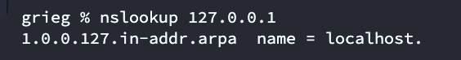

The name of this address is called localhost. A network number of 127 is not a network address. Ping 127.0.0.1 can be used to test whether the native TCP/IP protocol stack is normal.

# Exercise 2:

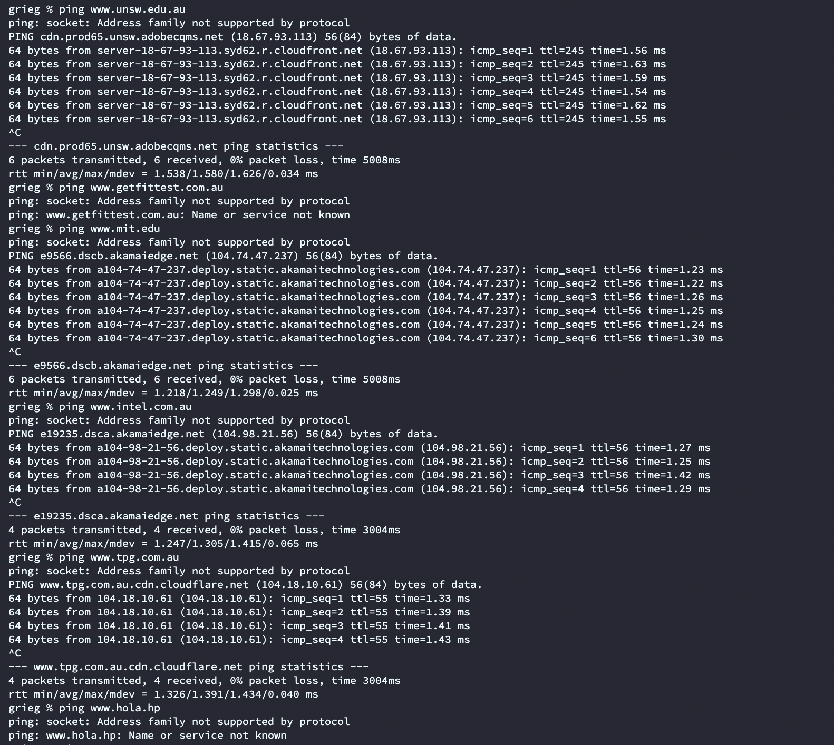

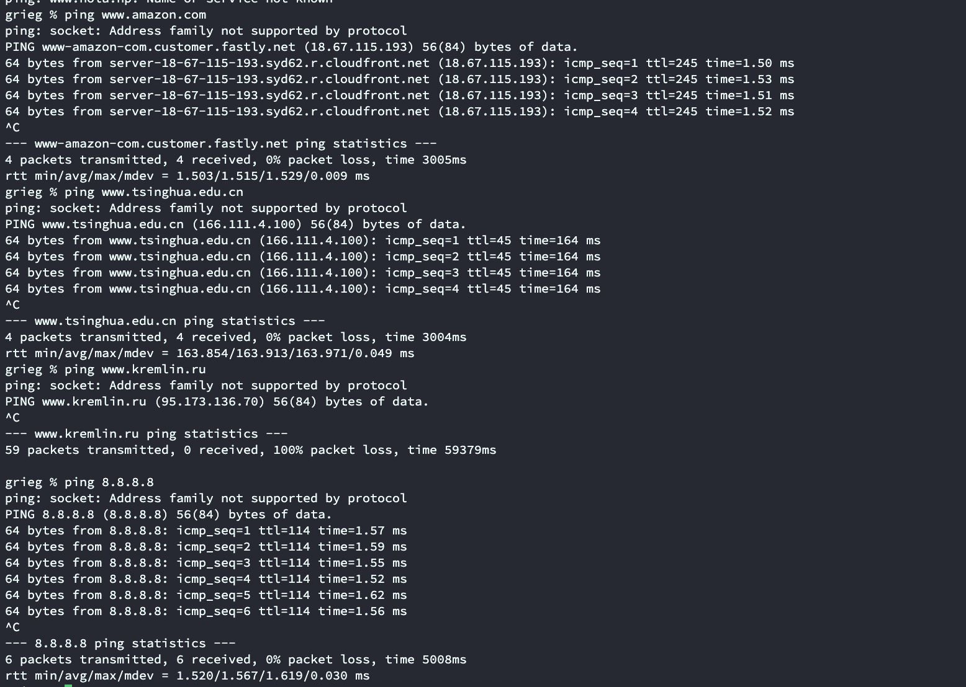

[www.getfittest.com.au](http://www.getfittest.com.au) is not reachable. I think the ‘getfittest’ maybe not a domain name.

[www.hola.hp](http://www.hola.hp) is not reachable. I think the reason is ‘hp’ is not a domain name like ‘com’.

[www.kremlin.ru](http://www.kremlin.ru) is not reachable, but the addresses are reachable from the Web browser. It should be that the server has set relevant policies to restrict the ICMP echo request message at the network layer; and the http protocol is used to access the web page, so this phenomenon occurs.

8.8.8.8 is pingable but the browser can not access, it may be the reason that it is only the IP address of a free DNS server provided by Google

# Exercise 3:

1.

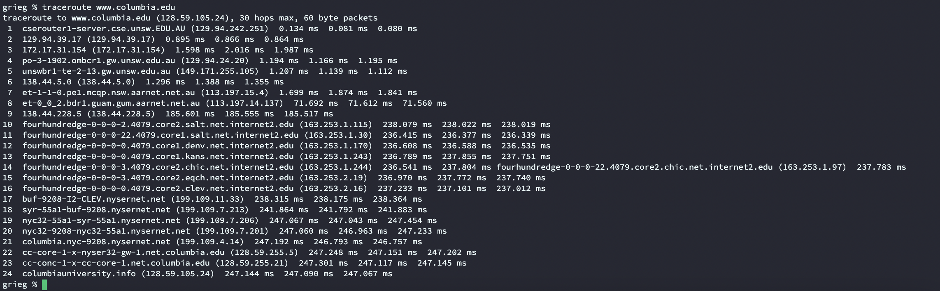

There are 23 routers between my workstation and [www.columbia.edu](http://www.columbia.edu). (the last one is not the router, but server.) I think the first five routers are all UNSW routers. The packets crossed the Pacific Ocean between the seventh and tenth routers. Through ping, it is found that the return time from the seventh router is longer, so the physical location of the router is checked from the seventh router, and it is found that the location of the tenth router has crossed the Pacific Ocean. So the packets cross the Pacific Ocean between the seventh and tenth routers.

2.(i)

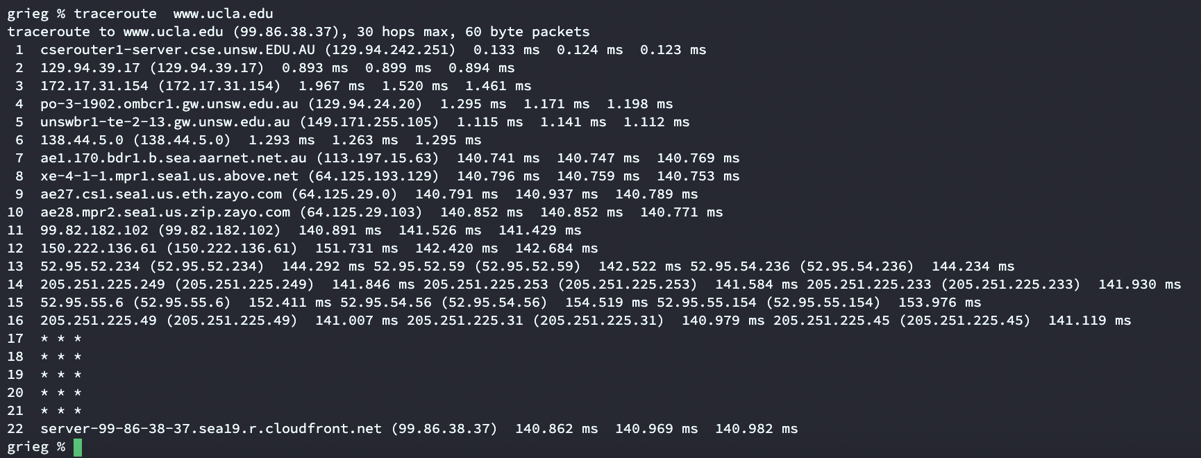

(ii)

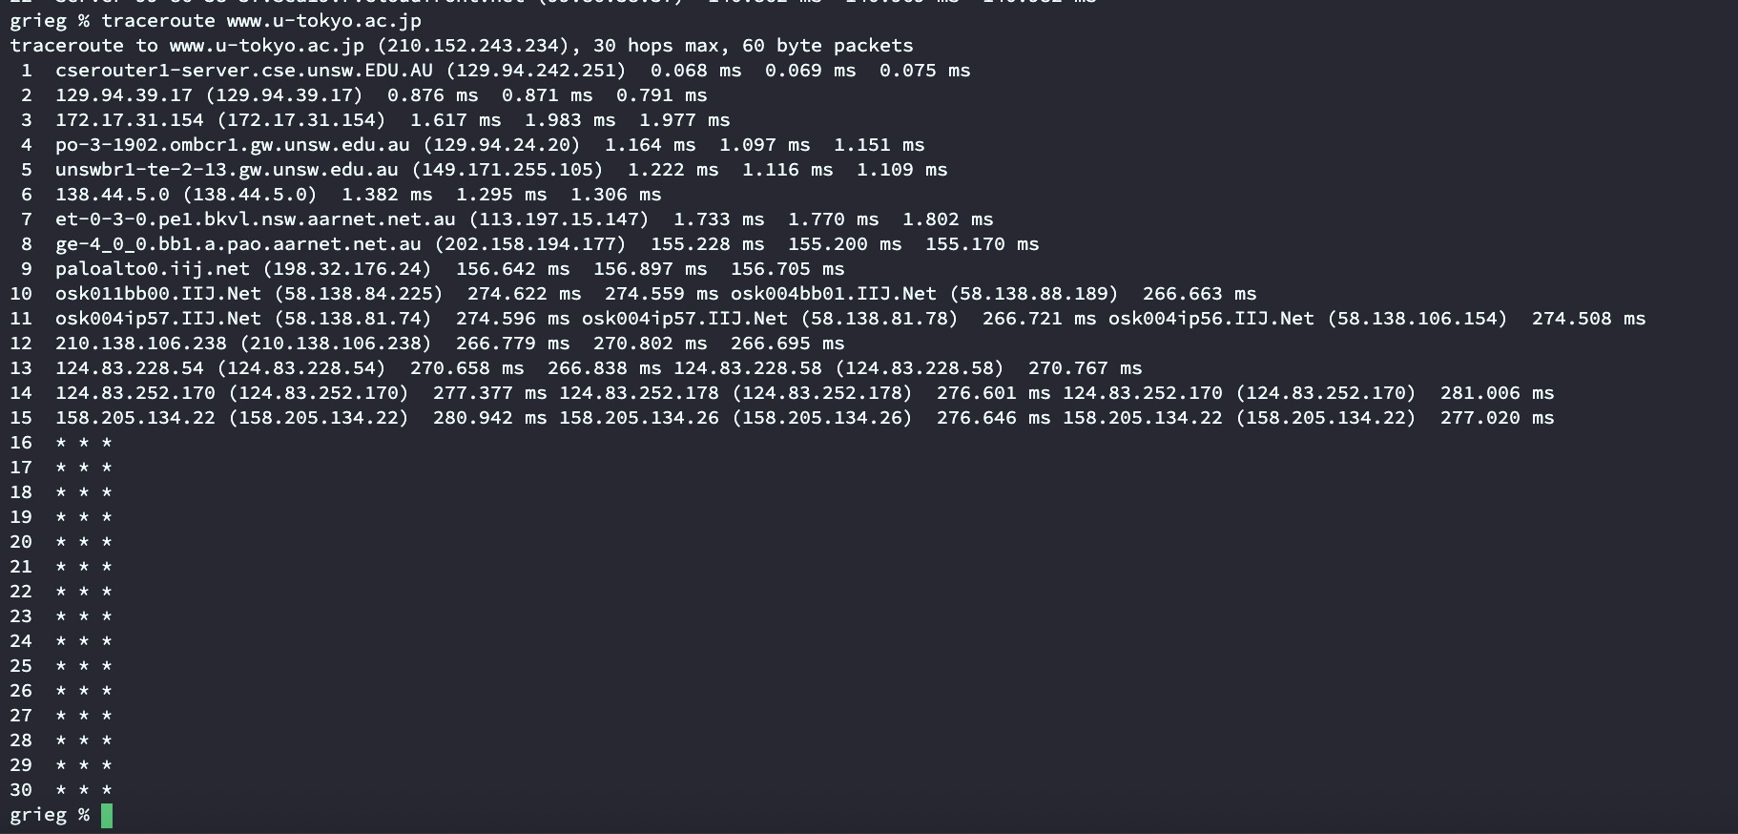

(iii)

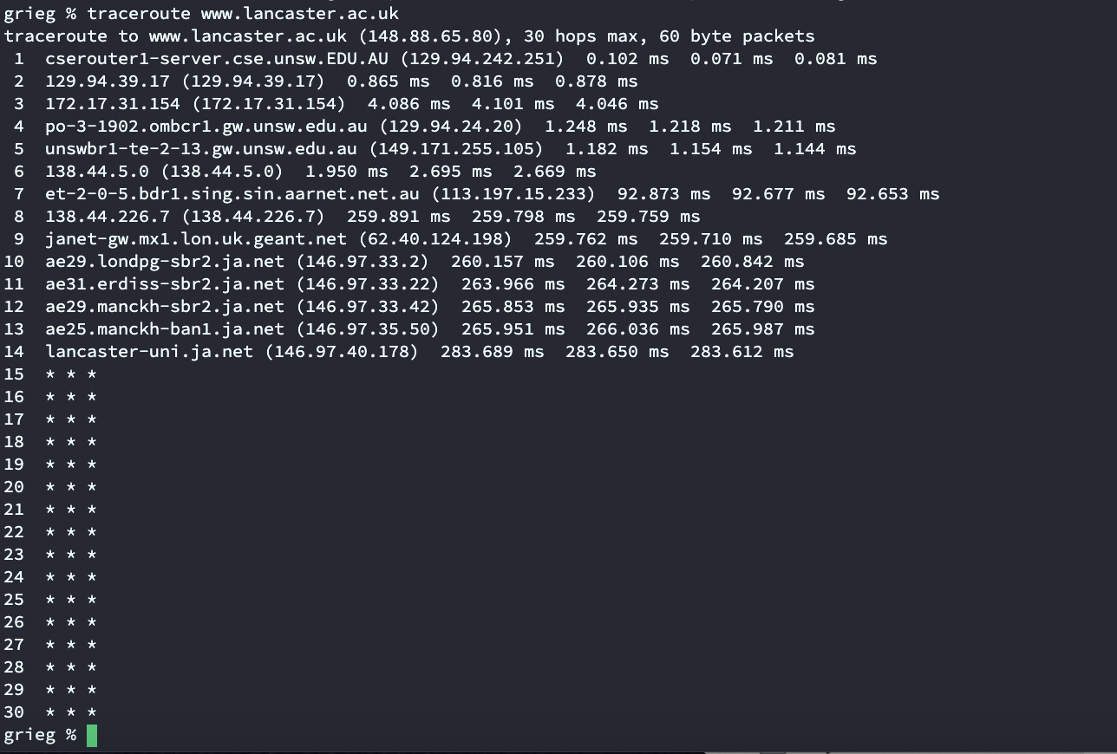

My machine's paths to these three destinations diverged on the sixth router (138.44.5.0).

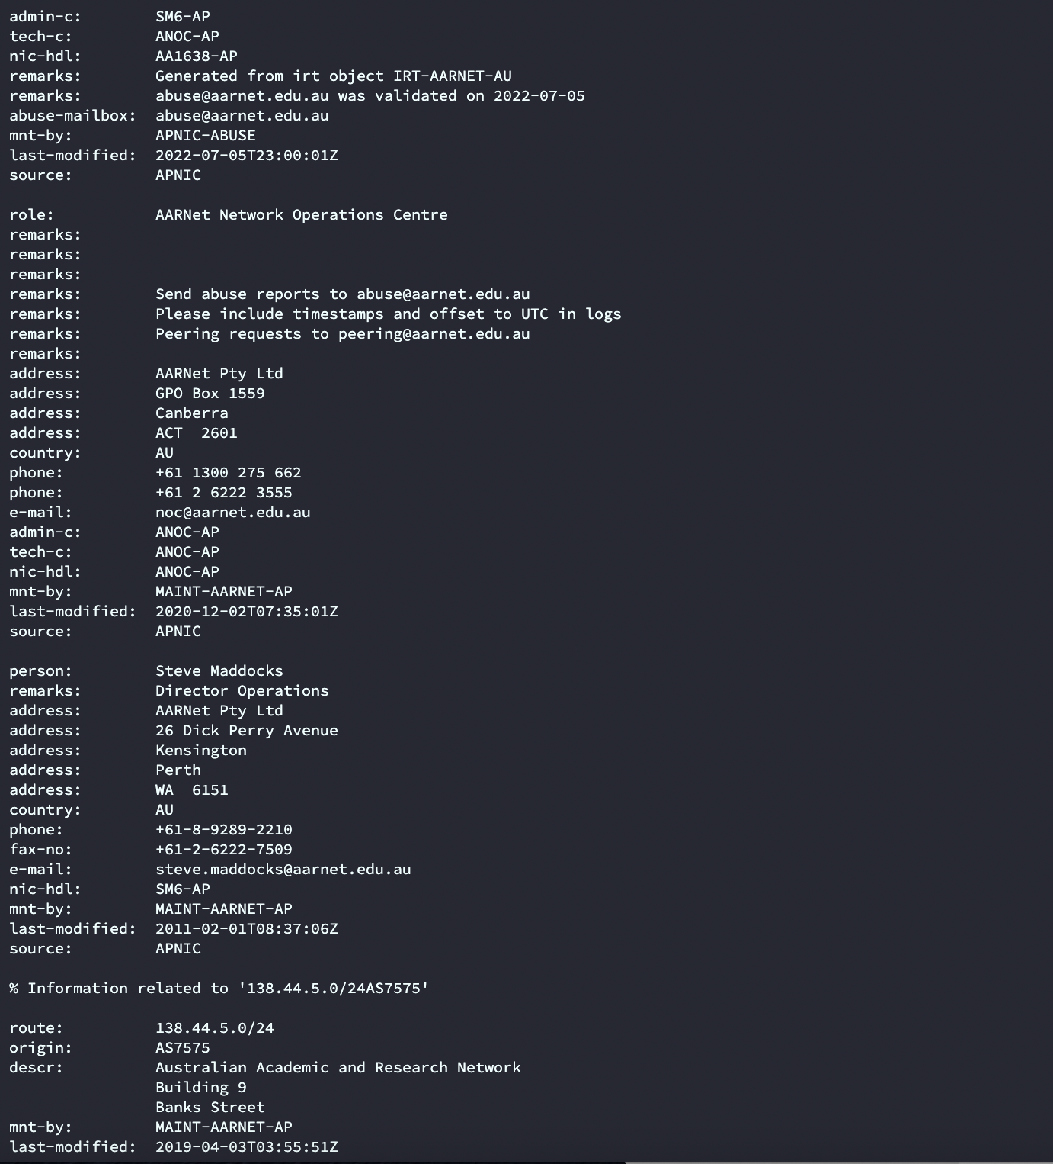

Using the commond ‘whois 138.44.5.0’can find that this one is the ISP of the UNSW.

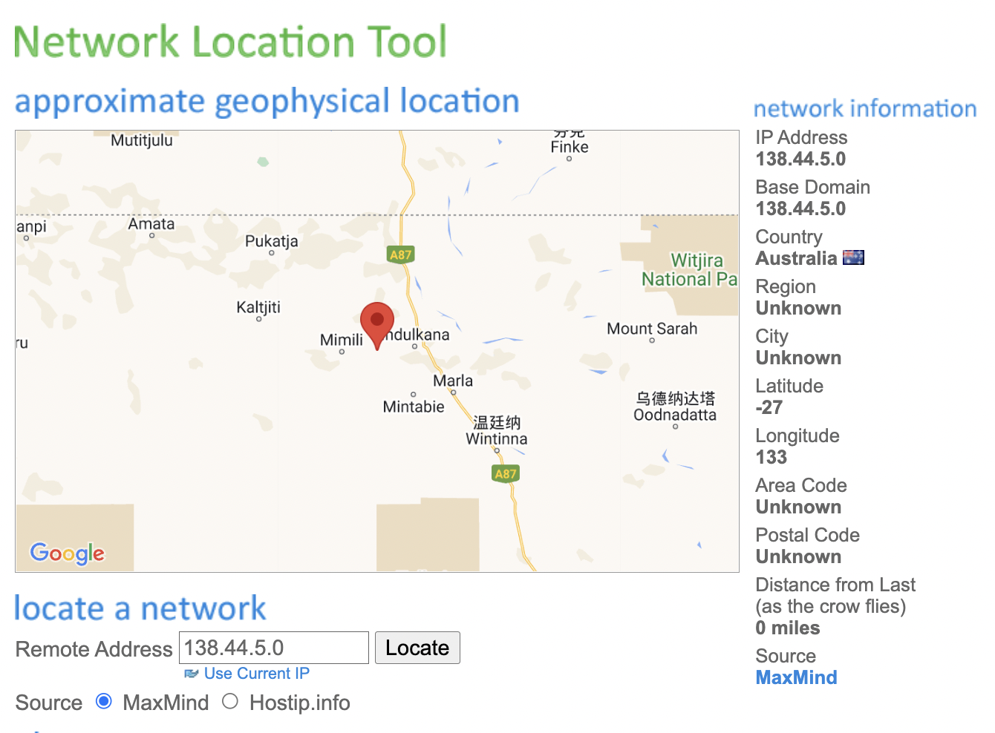

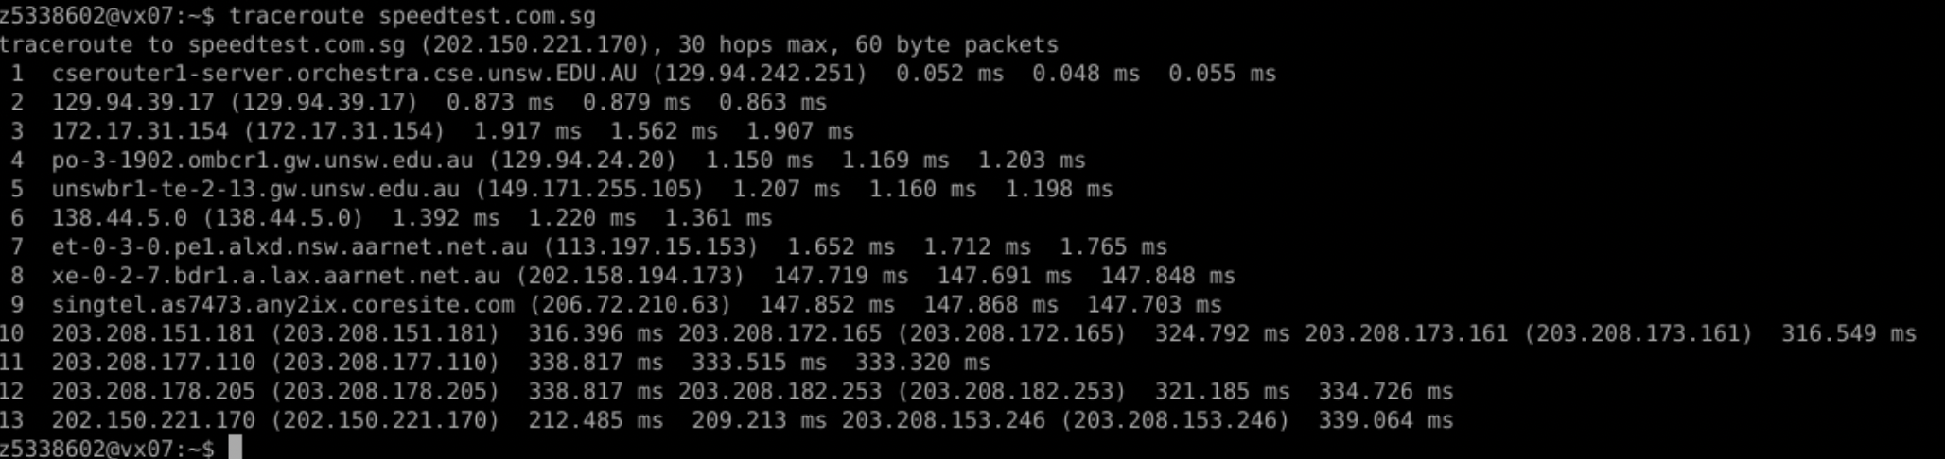

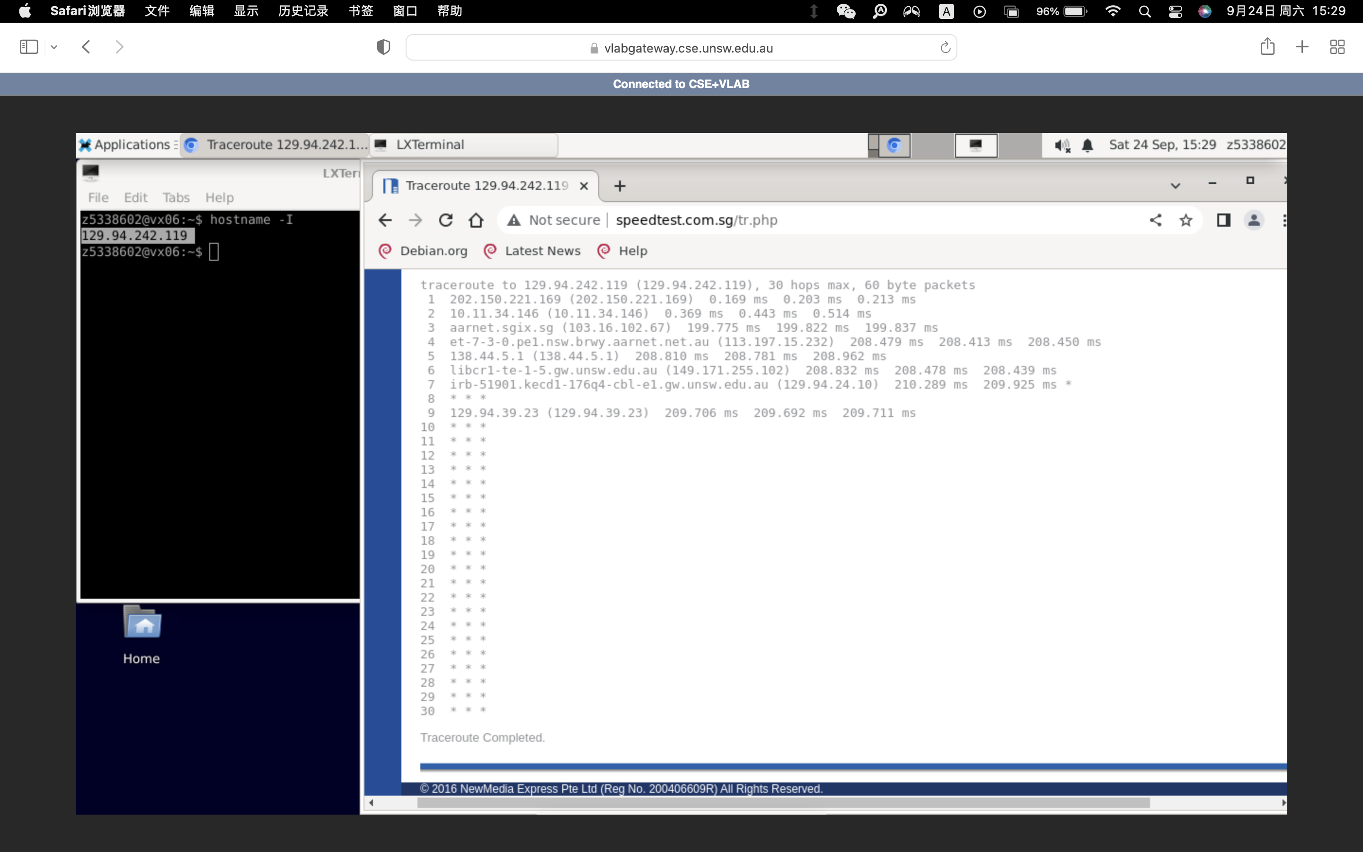

It can be seen that the physical distance from the local terminal to speedtest.com.sg and from speedtest.com.sg to the local terminal should be the same, but the number of hops on the path is not the same. So the number of hops on each path proportional to the physical distance is difference.

3.





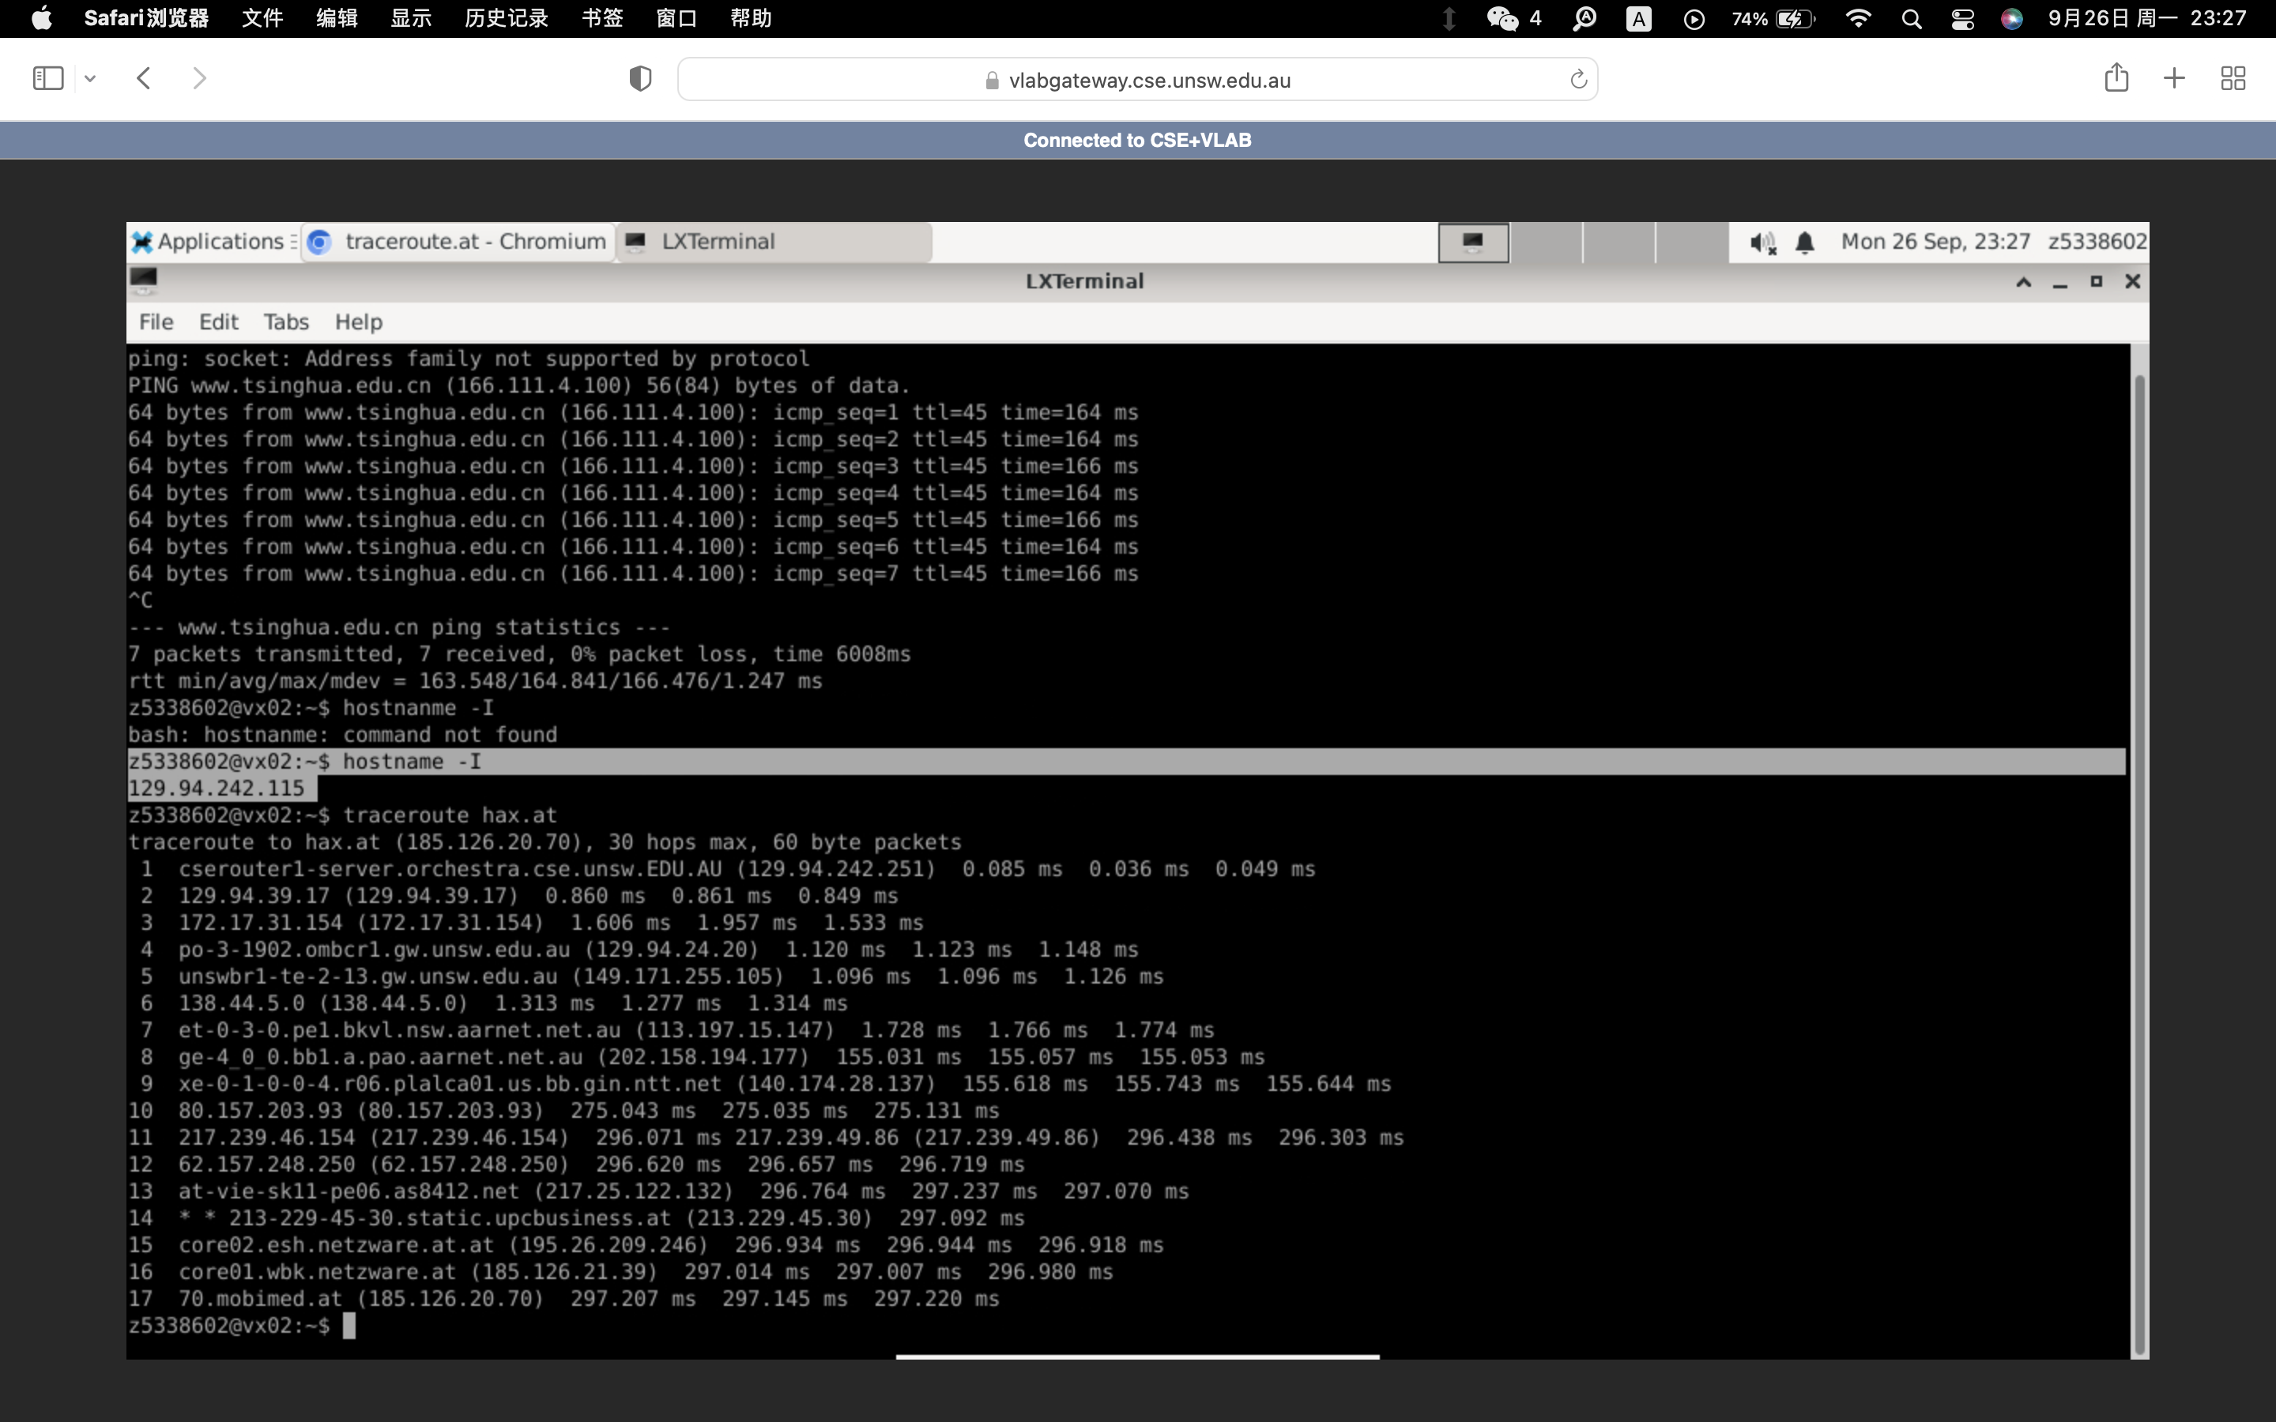

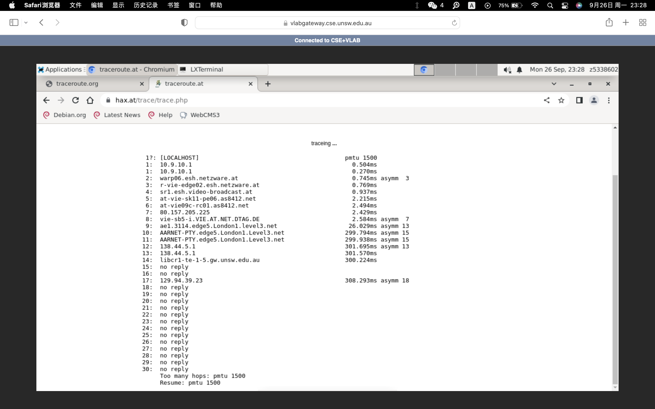

It can be seen that the net will go through different routing nodes and some of the same routing nodes, because the network can get a url through different paths, so the routing nodes through are not guaranteed to be exactly the same.

# Exercise 4:

1.

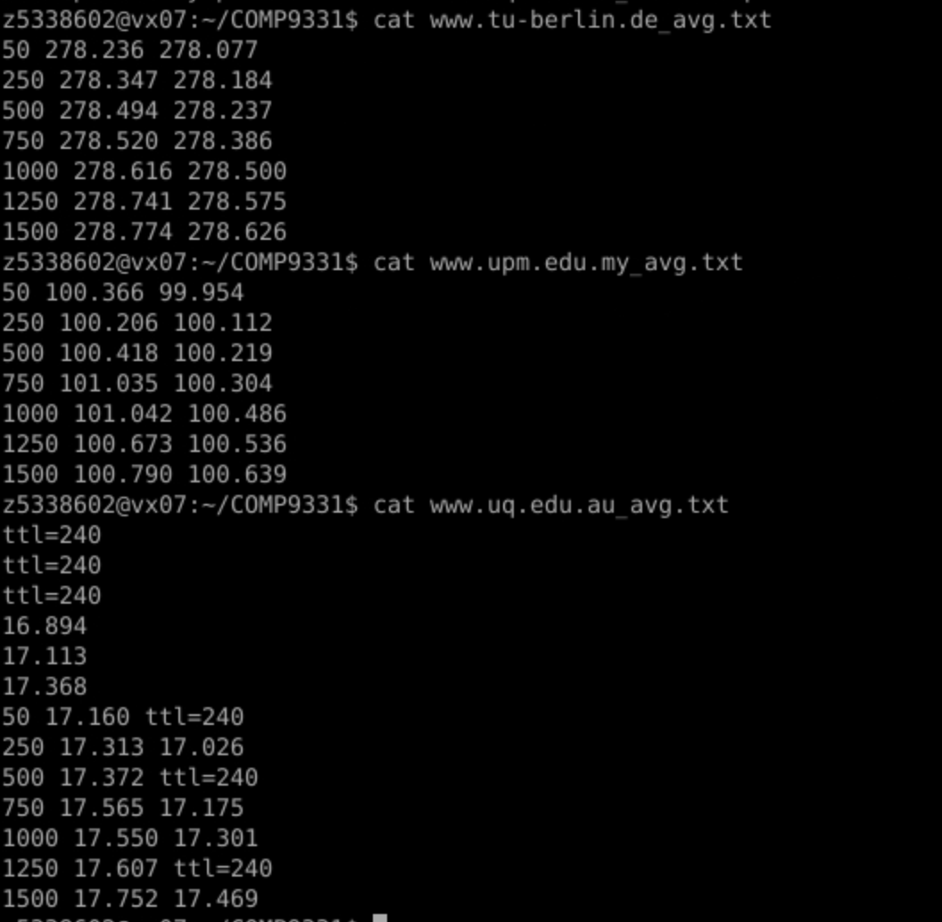

|  |  |  |  |  |
| --- | --- | --- | --- | --- |
| Host | Distance | RTT | T | Radio |
| [www.uq.edu.au](http://www.uq.edu.au) | 735km | 17.5ms | 2.45ms | 7.14 |
| [www.upm.edu.my](http://www.upm.edu.my) | 6750km | 101ms | 22.5ms | 4.49 |
| www.tu-berlin.de | 16105km | 278.6ms | 53.7ms | 5.19 |

2.

The delay to reach the destination is not constant. Delay includes four parts: transmission delay, processing delay, propagation delay and queueing delay. And the processing delay and queuing delay and transmission delay are all related to the packages size and the number of routers it passes through. The more routers it passes or larger the packages is, the more delay. So it is not constant.

The processing delay, queueing delay and transmission delay depend on the packet size. If it is huge, it may take more time to unpack and or the information in it. The propagation delay does not depend on the packet size.